PRACTICAL – 7

Practical Aim
To implement queue using array and linked list, and apply queue-based logic to number generation, and structure simulation problems.

Problem 1
A government office has a token counter that issues tokens to visitors. The counter can hold at most n tokens at a time. New visitors join from one end and are served from the other end in the order they arrived. If the counter is full, no new token can be issued, and if it is empty, no one can be served. Given a sequence of join and serve operations, implement this fixed-capacity token system and print the current front token after each operation. Report an error if an operation cannot be performed.
Describe how your solution tracks the front and rear of the queue. What happens to your front and rear pointers over time as join and serve operations keep happening, and does your solution handle the case where space appears to run out even though slots have been freed?
SOLUTION

OUTPUT
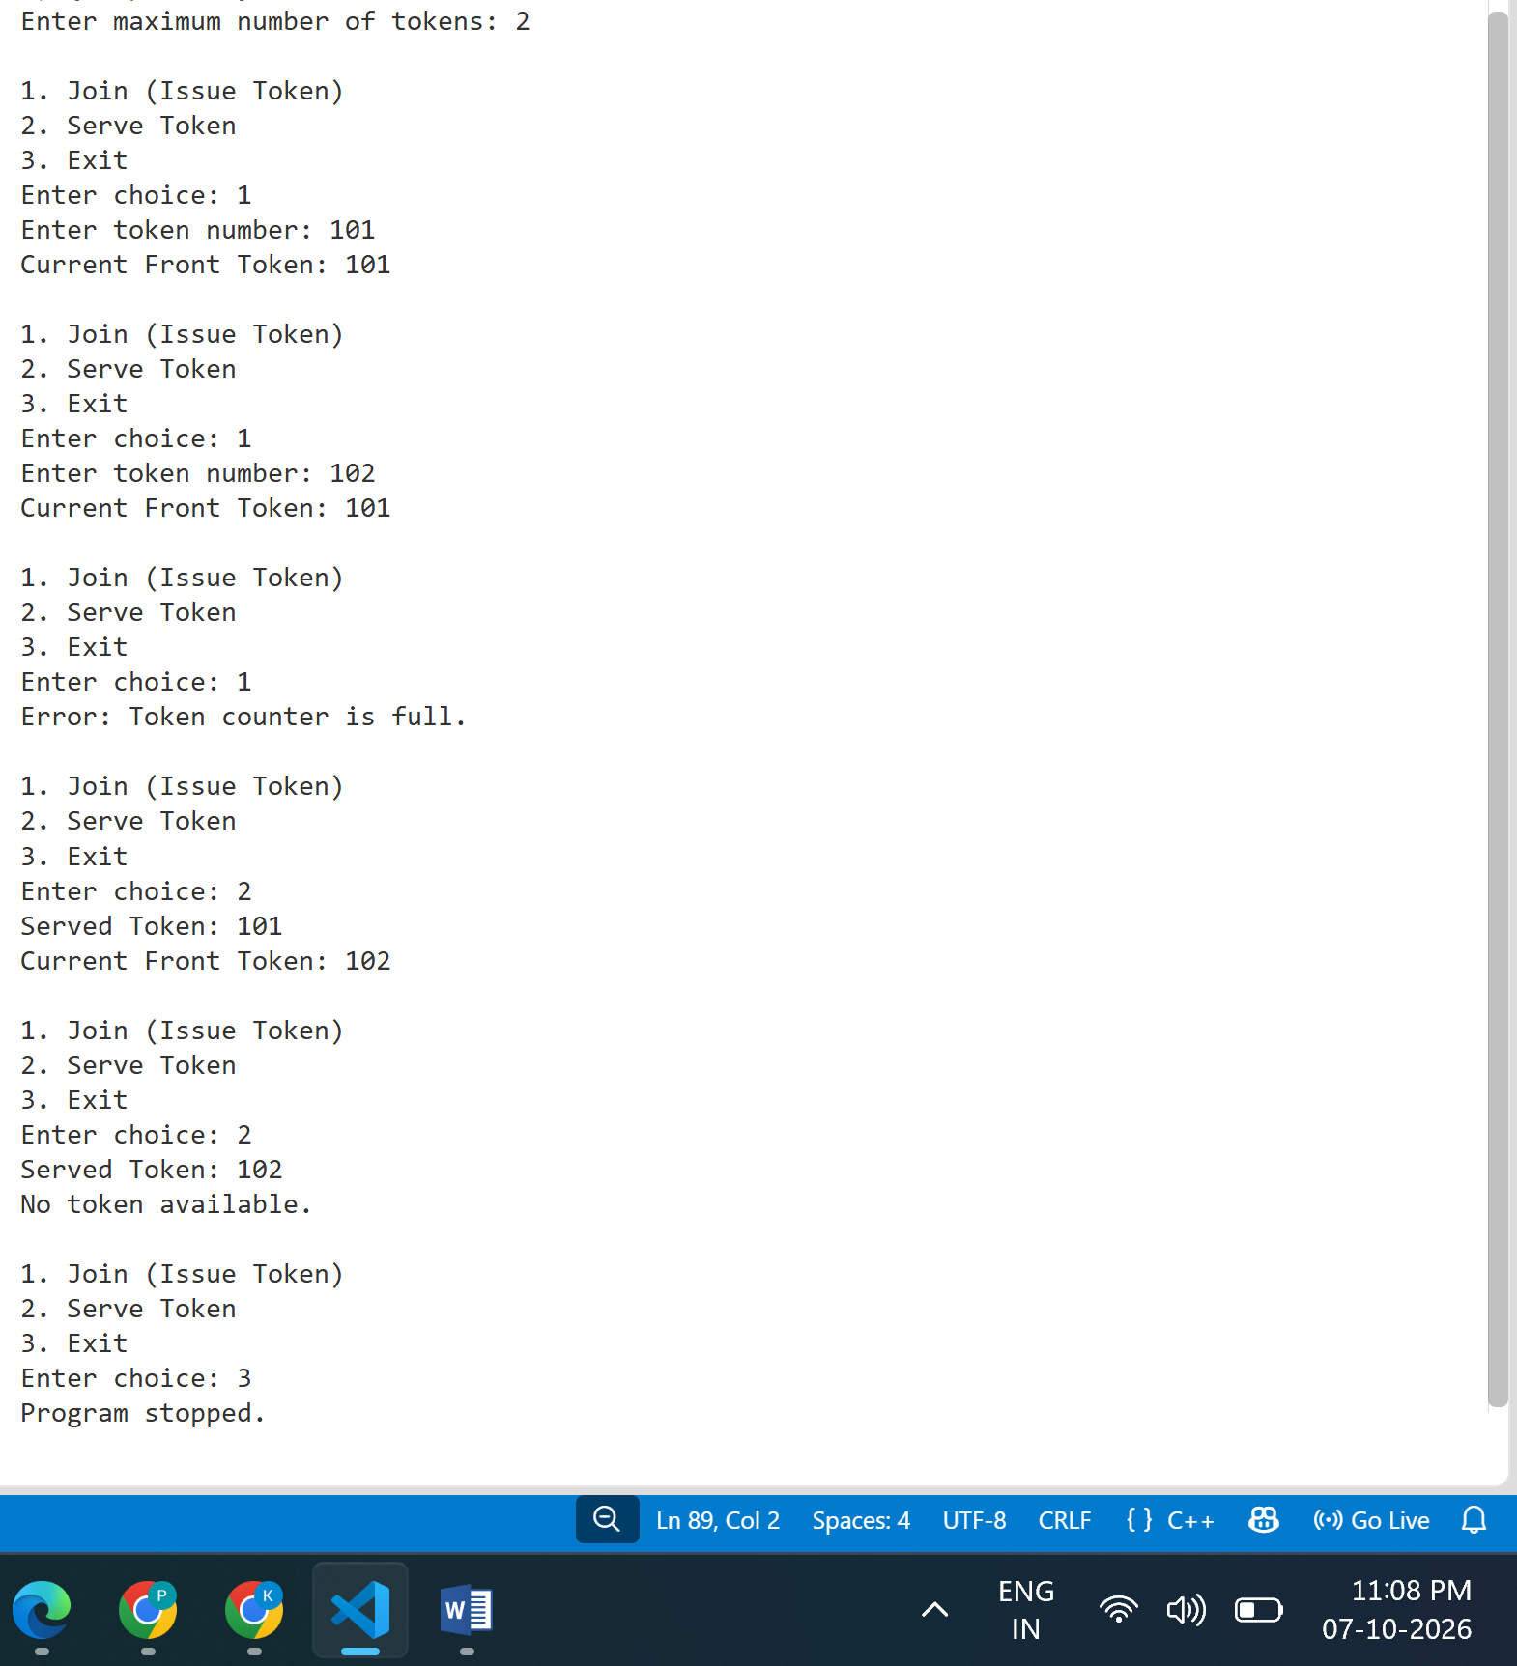

LEARNING
From this problem, I learned how to implement a queue with a fixed size. I understood that new tokens are added at the rear and tokens are served from the front, following the FIFO (First In, First Out) principle. I learned how to check whether the queue is full or empty before performing an operation. I also understood how the front and rear positions change after join and serve operations. Most importantly, I learned that in a simple linear queue, even if some spaces are freed at the beginning, the rear may reach the end of the array and cause false overflow. This helped me understand why a circular queue can be useful for reusing the freed spaces.

Problem 2
A hospital emergency ward receives patients continuously and attends to them strictly in the order they arrived, with no upper limit on how many can be waiting at once. New patients are added at the back and the doctor always attends to the patient at the front. Given a sequence of arrive and attend operations, implement this unlimited patient queue and print the current front patient after each operation.
Describe how your solution differs from Problem 1 in how it manages capacity. What happens in your solution when the attend operation is called on an empty ward with no patients waiting?
SOLUTION

OUTPUT
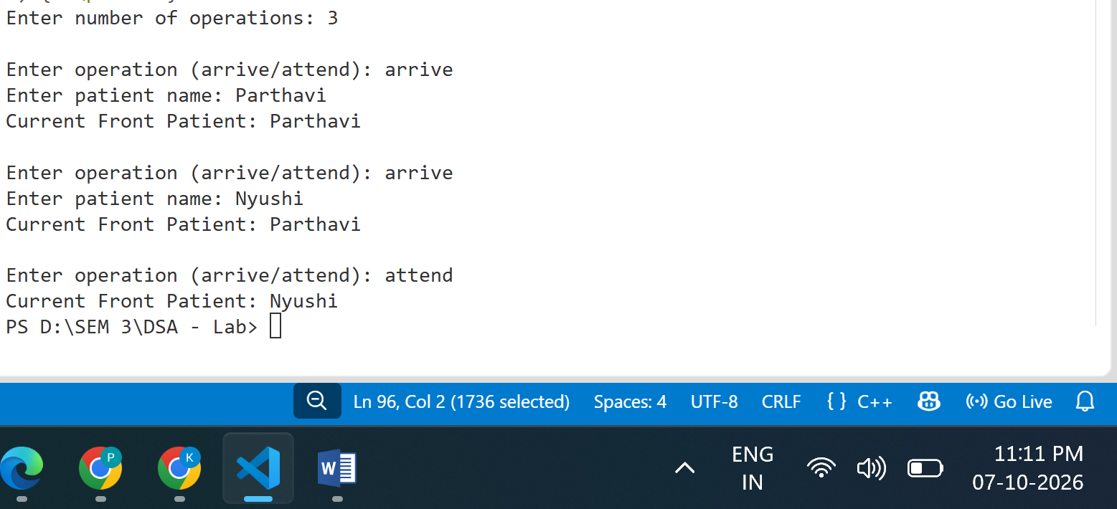

LEARNING
From this problem, I learned how to implement an unlimited or dynamically growing queue using a linked list. Unlike the fixed-capacity queue, there is no predefined maximum number of patients. I understood that every new patient is added at the rear, while the doctor attends the patient at the front. I learned how to dynamically create and delete nodes as patients arrive and are attended. I also learned how to safely handle the case when the attend operation is performed on an empty queue, by displaying an error message instead of trying to remove a non-existing patient. This problem helped me understand the advantage of dynamic memory allocation in queues.

